Disabled rights remain elusive
- Duncan Graham
Contributor
Posted: Wed, May 4 2016 | 09:05 am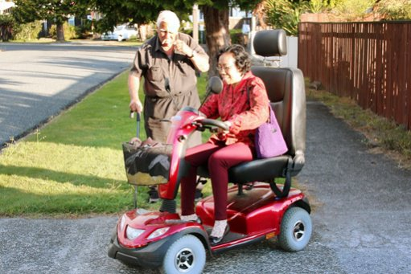

Topics

0
Share this article

- ∏
- 

- ∑

- ◊

Follow Us

- ∏
Well-handled: Endang Haryani tests a scooter as the owner watches.
Access to public buildings and services is supposed to be available to all.
But try climbing the steps into a bank, mall or government office if you use crutches or a wheelchair in Indonesia.
Not a problem in New Zealand, as rights advocate Endang Haryani discovered during a two-week tour of facilities for the impaired. It’s illegal to deny access to public buildings and transportation in the South Pacific nation, which claims to be a world leader in care for the disabled.
However, ideas and technologies that work well in one culture don’t always migrate successfully.
“A common sight is the handicapped and elderly using four-wheel electric scooters,” Haryani said. “They drive into malls and offices while seated on their little machines; they have access to busses, trains and special toilets.”
She said she would love to see that happening in Indonesia, ensuring independence.
“We could make similar scooters – but our roads and pavements are notoriously crowded and potholed and traffic ill-disciplined. There are few safe spaces,” she says.
“There are parking bays exclusively for handicapped drivers in NZ. Heavy fines are imposed on misusers. I don’t think this could happen in Indonesia.”
Haryani is the director of Yayasan Pembinaan Anak Cacat ( YPAC or Foundation for the Care of Handicapped Children ) in Malang, East Java.
There are 17 YPACs across Indonesia, originally established during the 1950s polio epidemic. Now the crippling disease has been almost defeated by the Salk vaccine, the YPACs care for children with all handicaps, physical and intellectual.
“Apart from access problems, attitudes also need to change,” Haryani said. “The disabled have rights and need to be accepted and treated equally.
“The idea that a handicapped child is a curse for sins committed by parents persists. Children can be locked away, hidden from neighbors. The kids don’t get schooling or the care they need. Those with autism get labelled naughty.
“At YPAC Malang we send staff into the community to try and dispel these myths and get families involved in rehabilitation.
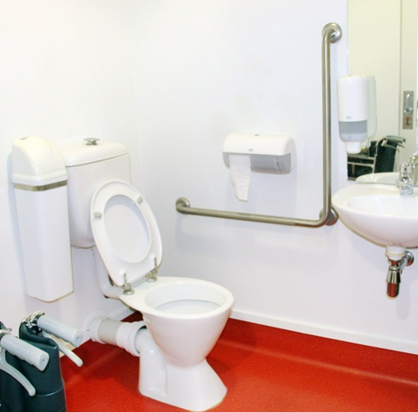Easy access:Accessible toilets are mandatory in all public buildings in New Zealand
“Early intervention can be effective. For example children with cleft palates and other disfigurements can have corrective surgery while still babies. Some hearing impairments can be reduced with speedy action.”
The air fares for Haryani’s fact-finding trip were paid by Jose Tavares, the Indonesian Ambassador to NZ, and she was hosted by the Rehabilim Trust.
This is a secular non-government group of volunteers set up three decades ago to help the handicapped in Indonesia. It was established after the late Colin McLennan, a Scout leader attending a meeting in Yogyakarta, was shocked to see crippled beggars.
He raised money in NZ, formed a partnership with an Indonesian doctor and created the Yakkum Foundation. Now funded by major sponsors in Indonesia, Europe and the US, Yakkum has expanded and has branches elsewhere, including Bali.
Three years ago, Rehabilim Trust chairman Bill Russell visited Malang to seek new seeding opportunities; he was surprised by a plaque on YPAC’s kitchen wall acknowledging NZ Embassy support more than 20 years earlier.
Since then the embassy’s Jakarta staff had changed several times and no one knew of the donation. Former ambassador David Taylor came for a look, was impressed and found more money to improve facilities.
The Rehabilim Trust followed with backing for a batik-making business using designs imitating the splash and drip painting techniques pioneered by the late American artist Jackson Pollock. Two Indonesian banks have ordered the batiks to be used as staff uniforms.
YPAC Malang is a secular organisation with around 130 students. Most live at home and visit daily for therapy and schooling. Some orphans stay on the premises.
Haryani was trained as an agricultural engineer and became a successful businesswoman. She got involved with YPAC as a part-time volunteer “because I wanted to give something back to the community for the many blessings received by my family”.
Later she was appointed to the board of doctors and community leaders. Her reforming zeal and ability to encourage business to donate through corporate social responsibility programs led to her election as director until 2018. This is an unpaid position.
“The way Kiwis look at the disabled is significantly different,” Haryani said. “The welfare system provides a minimum payment of NZ$262 a week for the sick and injured who can’t work.
“The Accident Compensation Corporation is a universal no-fault accident injury scheme providing free medical care and rehabilitation support. This often includes modifying cars so a person with lower limb damage can continue to drive using hand controls – and recover their independence.
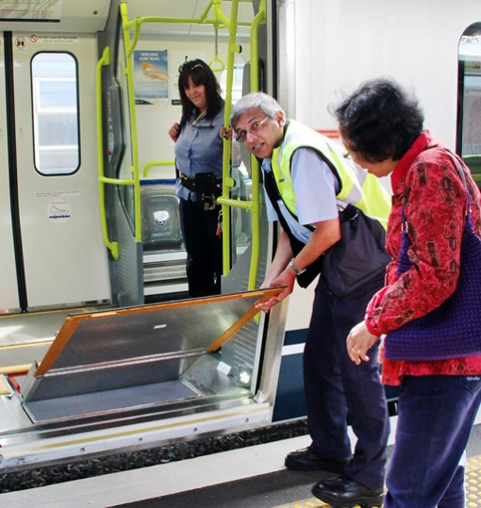Helpful innovation: Endang Haryani checks out a train ramp for wheelchair access in New Zealand
“There are community art workshops where the handicapped develop their skills in pottery, painting and crafts. This is an idea I think could transfer to Indonesia. These facilities are in town centers and available to the able-bodied.
“This means the disabled are not separated from the rest of society. They mix with everyone else so are not seen as being different. This is important.
“The slogan in NZ is ‘see the person, not the problem’. There are reports that President Joko “Jokowi” Widodo expressed surprise last year when he heard handicapped people sing during a ceremony to mark International Disabilities Day.
“Why should this be unusual? A person who can’t use their limbs can still use their brains and other faculties.
“British cosmologist Professor Stephen Hawking has motor neurone disease, yet wrote his best-seller A Brief History of Time from his wheelchair using technology which transferred his facial movements into words.
“Unfortunately our outdated laws still consider the handicapped to be incapable. Modern thinking is that they should and can contribute to society. Our job is to ensure they can reach their full potential as citizens with dignity.”
— Photos by Erlinawati Graham

